Equine Daily Dewormer Supplement Comparison Chart
Drs. Foster & Smith Educational Staff
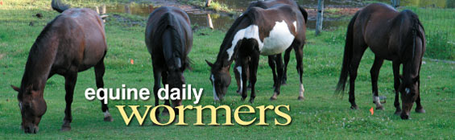
For most horse owners, daily deworming is a vital component of effective parasite control. In fact, when used in conjunction with a rotational deworming regimen, the use of medicated feed additives may be the simplest way to help prevent parasite re-infestation. Daily dewormers - commonly referred to as "wormers" - work to continually rid your horse of parasite larvae before they migrate into body tissues and begin to damage internal organs. They are also easy to use - simply add the recommended amount to your horse's daily grain ration. It is important, however, that your horse consumes the recommended dose everyday. Missed doses decrease dewormer levels in your horse's system and greatly decrease the wormer's effectiveness.
Wormer | Unique Benefits | # of  Servings  (up to*) | % Pyrantel  Tartrate | Form | Base | Helps Control
Continuex | Added wheat, rice hulls, and molasses increase palatability. | 400 | 2.11% | Pellet | Alfalfa
Equi Aid CW | Economically priced at around 30-cents per day to use. | 400 | 2.11% | Pellet | Alfalfa
Strongid  C-2X | Concentrated formula contains twice the pyrantel tartrate as Strongid C. | 80 | 2.11% | Pellet | Alfalfa
Nu-Image Guardian | Added biotin helps improve hooves, skin, and coat luster. | 80 | 2.11% | Pellet | Soybeans
Equi Aid SW | Minimal level pyrantel tartrate formula with higher protein and fiber levels. | 100 | 1.06% | Pellet | Alfalfa
Strongid C | Contains no artificial flavors. | 100 | 1.06% | Pellet | Alfalfa
*Based on the minimal recommended serving for a 1,000 lb horse. Number of servings will increase or decrease with a smaller or larger weight horse, respectively.

